Darwin’s Birds LAB
The Darwin’s Birds Lab allows students to have a hands on experience while exploring the key concept of natural selection. Students will reenact how different physical attributes of four different finches causes natural selection. The lab gives students a deeper understanding about natural selection and how certain attributes are advantageous and disadvantageous depending upon the environment in which they are found.
Texas Education Knowledge and Skills (TEKS)
B.7A analyze and evaluate how evidence of common ancestry among groups is provided by the fossil record, biogeography, and homologies, including anatomical, molecular, and developmental (Readiness Standard)
B.7C analyze and evaluate how natural selection produces change in populations, not individuals (Supporting Standard)
B.7E analyze and evaluate the relationship of natural selection to adaptation and to the development of diversity in and among species (Readiness Standard)

Supplies Needed
4 Cups per Lab group, A spoon, fork, and chopstick for each lab group or individual, Bag of Pasta, Paper Clips, Beads, Rice
Copies of Student Handout

Set Up
1 cup of pasta, rice, paperclips and beads for each lab station. Provide either a set of ‘bird beaks’ (fork, spoon, chopstick) to each lab station or for each student. Providing a set to each student will result in a faster lab with less interaction. A lab station set will be a longer lab with more group interaction.

DARWIN’S BIRDS: STUDENT HANDOUT

Background
When Charles Darwin visited the Galapagos Islands, he took notice of the small birds, finches, who populated the islands. The birds appeared to belong to the same genus of finches. There were 13 birds in all. They were similar in plumage, body shape and size. The striking difference was their beak structure. The 13 were divided into 4 main categories based on their beak structure and diet. Darwin supposed that all 13 had come from a recent, common ancestor. How the single species, the ancestor, became 4 and then 13 different species is your objective today!

At the station you should have a copy of the student handout. Begin by choosing which instrument (bird beak) you are going to use first. Will you use your fingers, a spoon, fork or chopstick first? Next decide which island to begin with. Rice Island, Paperclip Island, Bead Island, or Pasta Isle.
Take your tool and pick up some of the available food out of the cup. This represents how much food the bird type (Fingerbill, Spoonbill, Forkbill or Stickbill) is able to capture in a month’s time. Record how much food your bird type was able to gather in the Food Chart. After you have completed all of the Islands with all of the types of birds, then chart the data you collected into the Bird Success Graph. The Bird Success Graph will help you answer questions 1-10. Good luck and happy hunting!

Use the chart below to keep track of how much of each food type you gather with each beak type.
FOOD CHART | Rice | Pasta | Paperclip | Beads
Spoon
Fork
Fingers
Sticks

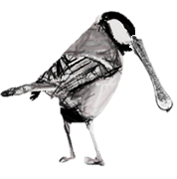
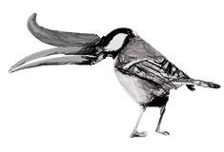
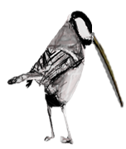
Forkbill
Spoonbill
Stickbill
Fingerbill
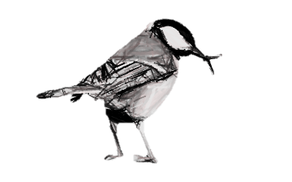

Each bird will need its own color for the Bird Success Graph. Set up the Y Axis by five (5, 10, 15, etc.) The X Axis represents the different islands: Rice, Pasta, Paperclip and Beads.
Spoonbill color = Green, Forkbill color = Red, Fingerbill color = Blue, Stickbill color = Yellow
BIRD SUCCES GRAPH
15
5
10
20
25
Rice Island
Pasta Island
Paperclip
Island
Beads
Island
0

Darwin’s Birds QUESTIONS
1. Please complete a chart with all four birds and all four islands. Give each bird a rating for each island. Ratings are as follows, ‘A’ for advantage on that island, ‘D’ for disadvantage on that island, and ‘N’ for neither/neutral on that island.
 | Rice Island | Pasta Isle | Paperclip Island | Bead Island
Spoonbill
Forkbill
Fingerbill
Stickbill

2. Which Islands would you likely see the Spoonbill? Why?

3.Which Islands would you likely see the Forkbill? Why?

4.Which Islands would you likely see the Stickbill? Why?

5.Which Islands would you likely see the Fingerbill? Why?

6. Fossils of all four birds have been found on all the islands. All four birds have also been traced back to a recently extinct ancestor found on Paperclip Island. Please explain why you think this may be important to understanding the evolution of the birds?

7. Most Spoonbills are found on Rice Island. Please explain why most Spoonbills are found here and not the other islands. Please use the words ‘competition’, ‘natural selection’ and ‘adaptation’ in context in your answer. Underline those words.

8. Fossils of Stickbills have been found on all four islands but Stickbills are only found on Paperclip Island as of now. Please explain why Stickbills live on only Paperclip Island but fossil remains have been found on all four islands.

9. Please explain in at least five sentences why there are more birds of one type on some islands but not on others. Please use the following terms in context in your answer: ‘natural selection’, ‘traits’, ‘inherited’, ‘fitness’, and ‘competition’. Underline those words.
10. In your opinion, in what ways could this experiment have been improved?

