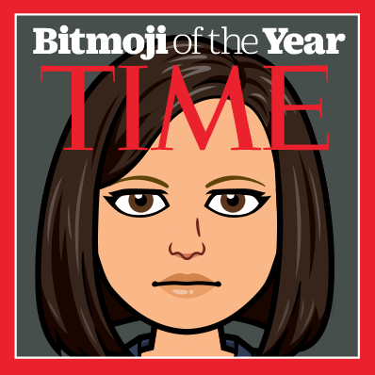
2020 Living History Journal

This event is history in the making! Nothing like this has occurred in our lifetimes and it will be important to document what life is like for us during this unique time! In 100 years from now, people will rely on sources of information to learn about what happened during the Coronavirus pandemic. Historians will examine primary sources of information such as diary entries, drawings, videos, and statistical data. They will also review secondary sources of information such as textbooks, documentaries, and essays. Secondary sources of information describe, interpret and analyze events, but primary sources of information are created by eyewitnesses that tell what happened from their viewpoint. You are the perfect person right now to create a primary source!

Your task is to create a historical journal/diary/scrapbook that depicts the events that are occurring in your life right now! Collect and create evidence that you can include to give as detailed a picture as possible to show what life is like for you now that we are living in the time of a pandemic. What is around you? What do you see, hear, think, feel?

Each week you will be required to do the following:

Personal Reflections Journal  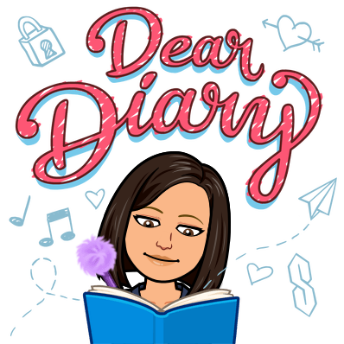 | At least 1 journal entry per week from your perspective (250+ words). You can free-write or answer the prompts below. You can write  your journal (paper, digitally) or record your voice narrating the journal.  Please open an Office 365 Word Document entitled Living History Journal and share this with me. Your journal entry should be completed by Wednesday 3:00 pm each week. I will begin checking at 3:00pm to ensure all entries are complete. Ensure you are dating each entry in your journal.  - What were your first reactions to hearing about COVID19? Did you think adults were over-reacting? Underreacting? How do you feel now?  - What did the government announce/declare/implement today?  - How does it impact your life?  - Does it make sense to you?  - How did your family respond?  - What is open in your neighborhood? What is closed?  - What does your neighborhood look like? Are people out? What do you observe? Take photographs of things you observe in your area to add to your journal entry as ‘evidence’ for your journal.  - How is today different from yesterday for you, your family, the country, the world?  - Did you see anything today that gave you hope? Anxiety? Fear?  - What does your family need today that you might not have/have enough of/ have the ability to acquire?  - What would you tell yourself 2 weeks ago?  - What are you grateful for today?  - What made today special? How have you connected to others?  - What are you craving today that you can’t easily access?
News Headlines and/or Artist Interpretation | 2 screenshots of headlines from national or local newspapers per week.  For each headline include a minimum of 5 sentences about your reaction/how it makes you feel/what it makes you wonder. In your reaction, include at least one quote from the news article itself.  Or  1 screenshot of headlines from national or local newspapers per week and  1 of the following:  - Letters, emails and/or texts between family/friends  - Photograph compilation (e.g., “A day in the life”)  - Drawing, paintings, songs and/or other pieces of art work  - Interviews with parents and other family members  - Investigation/report (see below for example topics)  - Your choice (check in with me on this)  For each item above, include 5 sentences about your reaction/how it makes you feel/what do you learn/what it makes you wonder.  You must have at least 1 interview over the course of the project.  Your headline and/or other item will be submitted by Friday 3:00 pm  each week. These should be added to your Office 365 Word document. Ensure you are dating each entry in your journal.

How you create your scrapbook or digital diary/journal is up to you. You will be assembling your ‘story’ and you can focus on what aspect of your journey you wish to choose. In this scary time, you might want to focus on the positive things you and your family are doing, and the things that you are learning, or ways you are growing. There are many amazing ways that community members are coming together to help each other in these unusual times! You will definitely want to include the exact dates on any items that you produce!

Things you may want to investigate or report on:

• Remote learning: School from home? What are you learning on your own? What do you miss?
• Statistics: Numbers and patterns in the growth of the pandemic
• Stories of people helping others in the community and your personal reaction to them
• Health care workers (how do we protect and celebrate?)
• Politicians: How are different leaders handling the situation? Your impression of them?
• Daily life inside: How have you adapted? Tips? Daily routines? How are you getting food?
• Fact or Fiction? What are you wondering? (Inquiry questions)
• Connections to other situations where people have been in isolation or extreme situation (e.g., fictional
stories and/or historical accounts such as Anne Frank)

If there is another area that you would like to focus on, please discuss with your teacher. As you work on your
Historical journal, submit to Ms. Phillips your weekly items. She will track that you are completing tasks each
week and will provide some feedback as you progress. We will work on this project for approximately 6-8 weeks. At the end of the project, you will reflect on how your thinking has changed from the beginning of the project to its end. This is why it is important to date every item, especially journal entries, so once you have completed the project, you will have a record of your thoughts along the way. 6-8 weeks from now, things might be quite different.

